APPLICATION for SEXUAL VIOLENCE ADVOCATE TRAINING
TO REGISTER: Please complete and return to CONTACT.

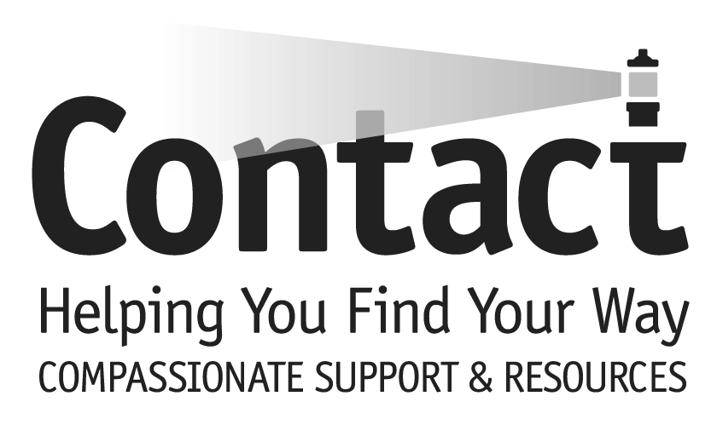

PO Box 333 – Moorestown, NJ 08057

Office: 856-234-5484 Fax: 856-778-3880
email: info@contactburlco.org
website: www.contactburlco.org
333 – Moorestown, NJ 08057

I am interested in: Training Fee

______Daytime Sessions _____$50.00 (to cover cost of training manuals/materials-
partial refund available)
______Evening Sessions _____$250.00 (education only/no volunteer commitment)

______Summer or Saturday Sessions (circle)

- Personal Information

Name:_____________________________________________________________________________

Address:___________________________________________________________________________

Phone: (H)________________________________(C)_______________________________________

Emergency Contact:________________________________________Phone____________________

E-mail:___________________________________Website:__________________________________

Age Group (circle one) 18-39 40-65 65+
CONTACT volunteers must be 18 years old and a high school graduate at time of application.

- Skills and Interests

Education Background/Training:

Current Occupation:___________________________________________________________________

Hobbies, Interests, Skills:

Previous Volunteer Experience:

- General

Write a brief statement why you wish to volunteer for CONTACT of Burlington County:

______________________________________________________________________________________
_______________________________________________________________________________________

What do you think are your strengths and weaknesses relating to people in crisis?

Have you taken CONTACT training in the past?________

If yes… When__________________________ Where_________________________________

Have you ever been convicted of a crime in any state or country?_________________

If yes, please provide details__________________________________________________

4. Commitment (must choose one)

_____Required training course (50 hours) and one year of volunteer service to CONTACT
Sexual Assault Services (4 shifts per month).

_____Required training course for education only with no volunteer service commitment.

5. References

How did you learn about CONTACT and its volunteer training program?

_______________________________________________________________________________________

List name and phone number of two references:

Name_____________________________________ Phone_________________________________

Name_____________________________________ Phone_________________________________

Please read this statement carefully and acknowledge acceptance by your signature below:
I have truthfully answered all questions in this application and agree to honor the service/fee commitment I have chosen. I agree to be on-time and attend every session in its entirety. Realizing that confidentiality is the cornerstone of the CONTACT program, I agree that I will keep in strict confidence any information that should come to me during training sessions. I understand a Background Check may be required. I agree that I may be asked to withdraw from training at any time. I acknowledge that I may resign from training at any time. I also agree that in the event of my withdrawal or resignation, I will keep confidential any and all information I know related to the work of CONTACT.

Signature_________________________________________________ Date_________________________

CONTACT of Burlington County
VOLUNTEER DESCRIPTION:
Confidential Sexual Violence Advocate

Reports to Sexual Assault Services Director or the Executive Director of CONTACT of Burlington County.

Qualifications
- Must be at least 18 years of age and a high school graduate at time of application
- Successful completion of the standardized NJ Sexual Assault Advocate Training and NJ Confidential Sexual Violence Advocate Certification
- Successful completion of required apprenticeship

Requirements
- Demonstration of non-judgmental attitude
- Adherence to the philosophy, policies and procedures of Sexual Assault Services and CONTACT of Burlington County.

Responsibilities
- Confidentiality: sign an Oath of Confidentiality related to program
- Anonymity: agreement to maintain appropriate anonymity
- Attitude: use of non-judgmental attitude maintained through training skills
- Commitment:
- serve 4 “on-call” shifts per month which may include accompaniment in a hospital emergency room, police station or court
- provide supportive telephone counseling and referral
- participate in outreach, special events, fundraisers and volunteer training when available
- Help plan and implement volunteer training when available
- Help plan and implement outreach education when available
- Length of Service: commitment of at least 1 year of service
- In-Service: commitment to continuing education by attending scheduled supervision/in-service meetings.

Reason for Dismissal
- Violation of the pledge of confidentiality of the client.
- Violation of the pledge of appropriate anonymity.
- Inappropriate contact or meeting with clients.
- Violation of Center policies and/or procedures.
May 2014

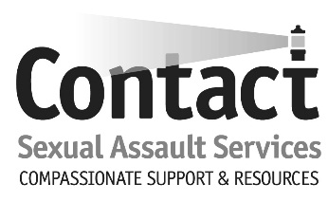

Confidential Sexual Violence Advocate Training Class

Phone number: (856) 234-5484

Website: www.contactburlco.org

Wednesday, March 11 - Class 1: Introduction, History of Sexual Violence and Violence Against Women

Monday, March 16 - Class 2: Cultural Competency

Wednesday, March 18 - Class 3: Counseling Skills

Monday, March 23 - Class 4: Sexual Harassment, Human Trafficking, and Domestic Abuse

Wednesday, March 25 - Class 5: Drug Facilitated Sexual Assault

Monday, March 30 - Class 6: Child Sexual Abuse and Adult Survivors of Child Sexual Abuse

Monday, April 6 - Class 7: Legal Issues (Guest Speaker – Victim Witness)

Wednesday, April 8 - Class 8: Medical Issues (Hospital Visits, Guest Speaker – SANE Coordinator)

Monday, April 13 - Class 9: Response to Trauma and Survivor Coping Methods, Mental Illness and Substance Abuse, Hotline Calls-Special Considerations

Wednesday, April 15 - Class 10: Referral Methods and Community Resources & Program Procedures

Monday, April 20 - Class 11: Suicide (Guest Speaker – Theresa Tobey)

Wednesday, April 22 - Class 12: Services to Significant Others

Monday, April 27- Class 13: Burn Out and Vicarious Trauma, Self-Care

Wednesday, April 29 - Class 14: Final Review, Exam, Exit Interviews

*Class topics and dates are subject to change*

. If you cannot make a training date, you must contact the Sexual Assault Services Director, Jillian Kotarski, at least 24 hours before the class is set to begin.
Email: jkotarski@contactburlco.org

